VEGFED Survey Application - User Manual
VEGFED system consists of two main parts: a Mobile Application used by Surveyors to collect vendor data on the field, and a Web Admin Panel used by Administrators to review and approve these surveys.

1. Mobile App (For Surveyors)
The mobile app is designed to work seamlessly in the field, even in areas with poor internet connectivity.
Getting Started
- Login: Open the app and log in using your Surveyor credentials.
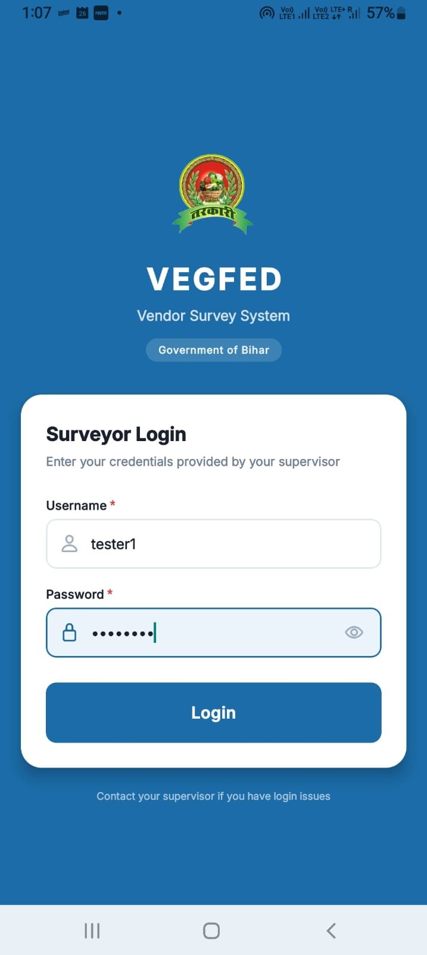

- Dashboard: Once logged in, you will see a summary of your surveys categorized by status: Pending, Approved, and Rejected.
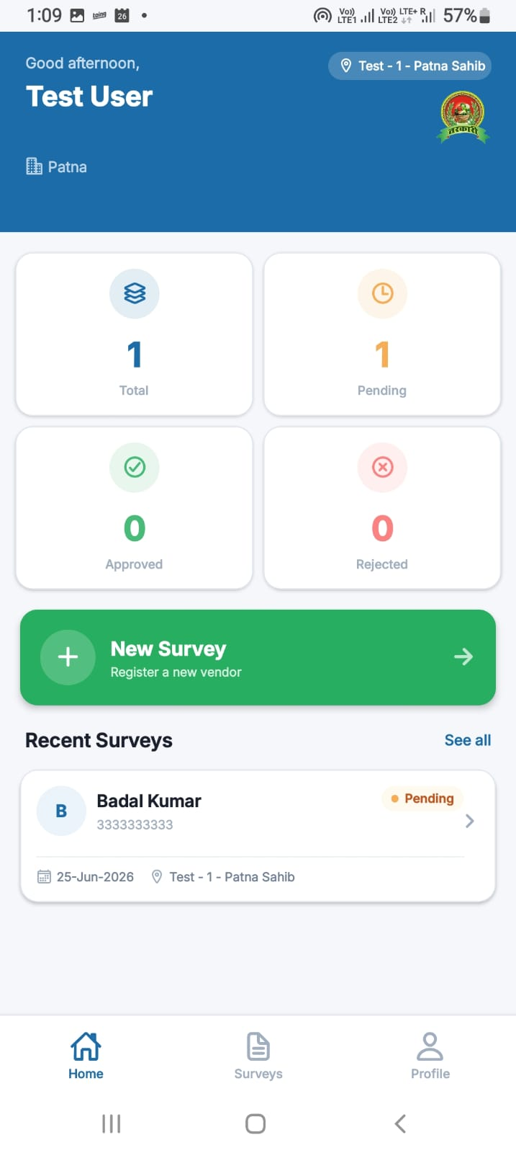

Creating a New Survey
- Tap the New Survey button from the dashboard.
- Personal Info: Fill in the vendor's Full Name, Aadhaar Number, Mobile Number, Gender, and Age and click “Next”.

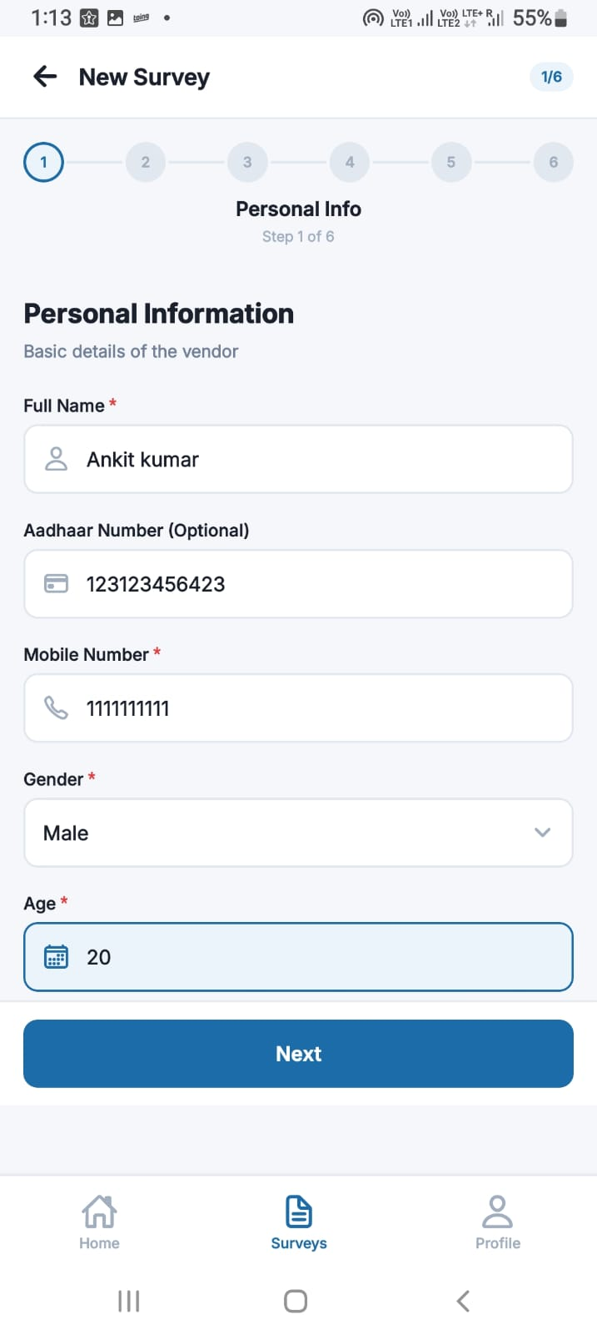

- Address & Stall: Provide their residential address, stall ownership (Own/Rented), stall setup type, nearest landmark, and selling location and then click “Next”.

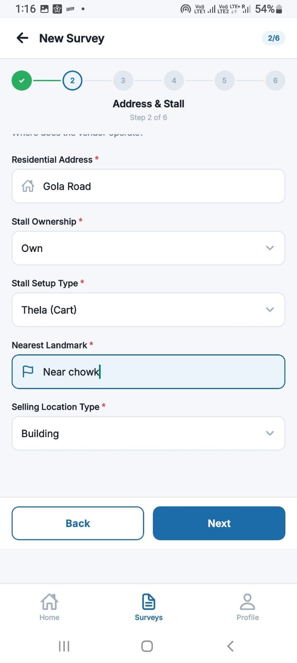

- Business Info: Enter details about their experience, daily sales volume, supply source, daily income, and transport details, and then click “Next”.

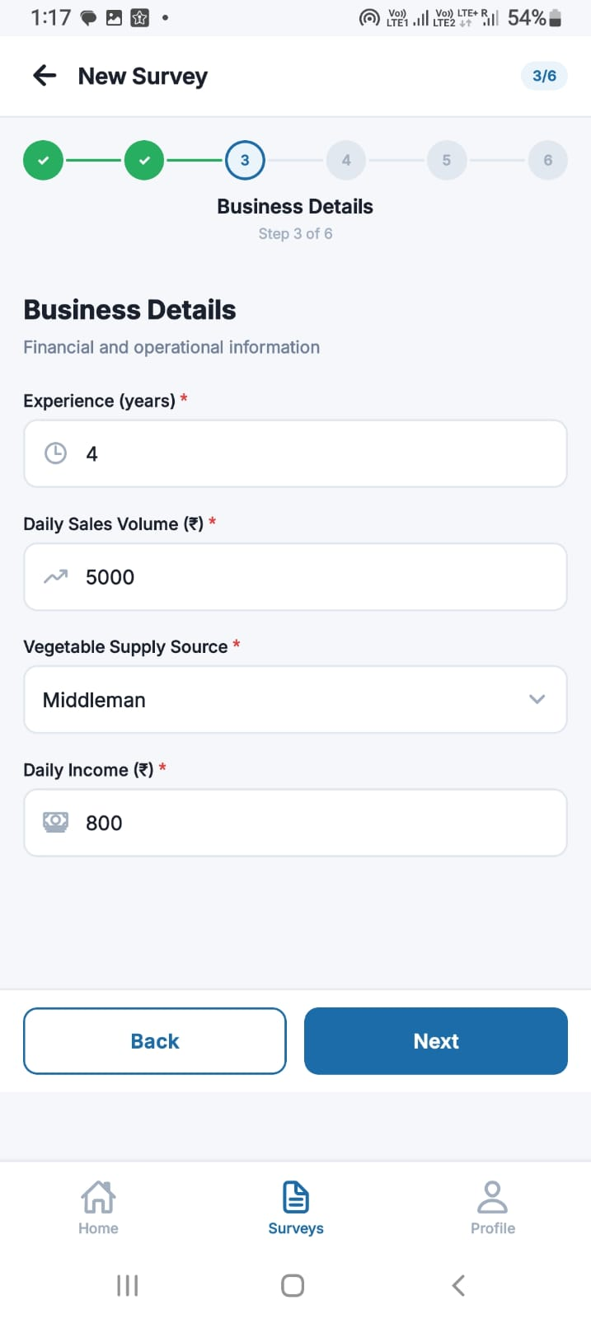

- Transport and Finance: Enter details regarding time to reach market to buy vegetables (in minutes), mode of transport, daily transport cost (in ₹), whether vendor has an active loan (if yes, provide details), survey type, and then click “Next”.

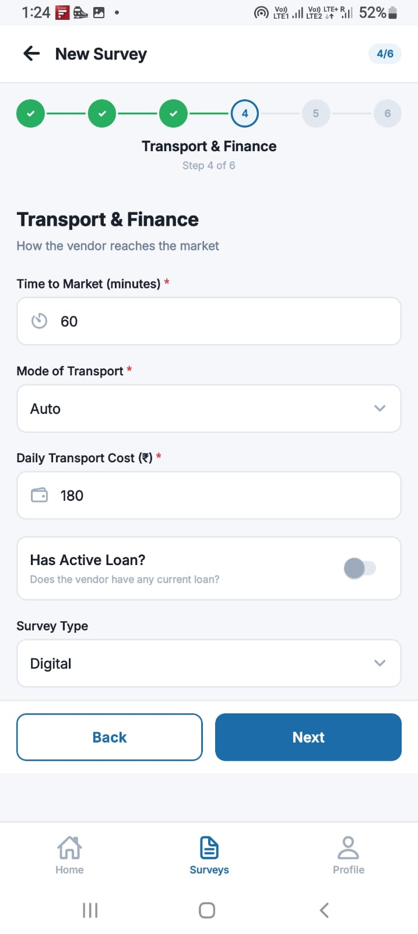

- Photos: Take clear photos of the Vendor and a photo of the Stall.
- Location: Click to “Capture GPS Location” button. The app will capture the GPS coordinates of the stall, and then click “Next”.

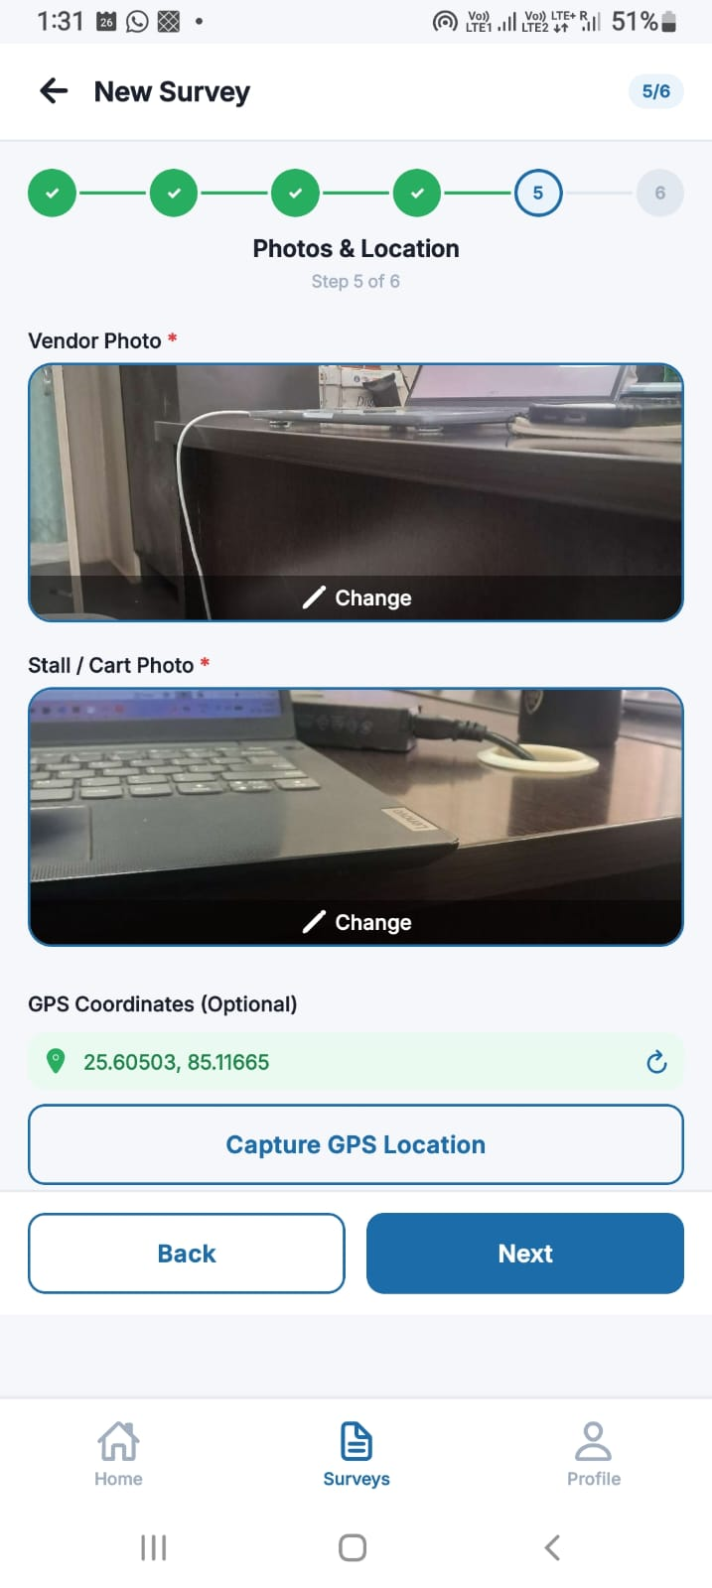

- Submit Survey: Review the details and click Submit Survey.

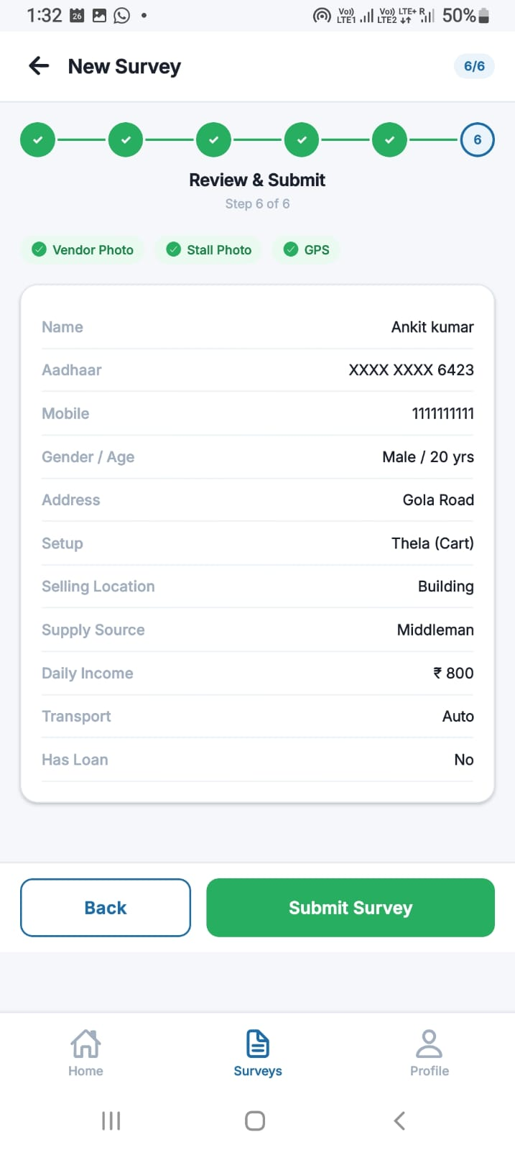

TIP
Offline Mode: One of the best part of this app is when you don't have internet access, the survey will be saved as a "Draft" or placed in the "Offline Queue". The app will automatically sync these to the server once you regain connectivity.
Reviewing and Editing Surveys
- Survey Details: Tap on any survey from your dashboard to view its full details.
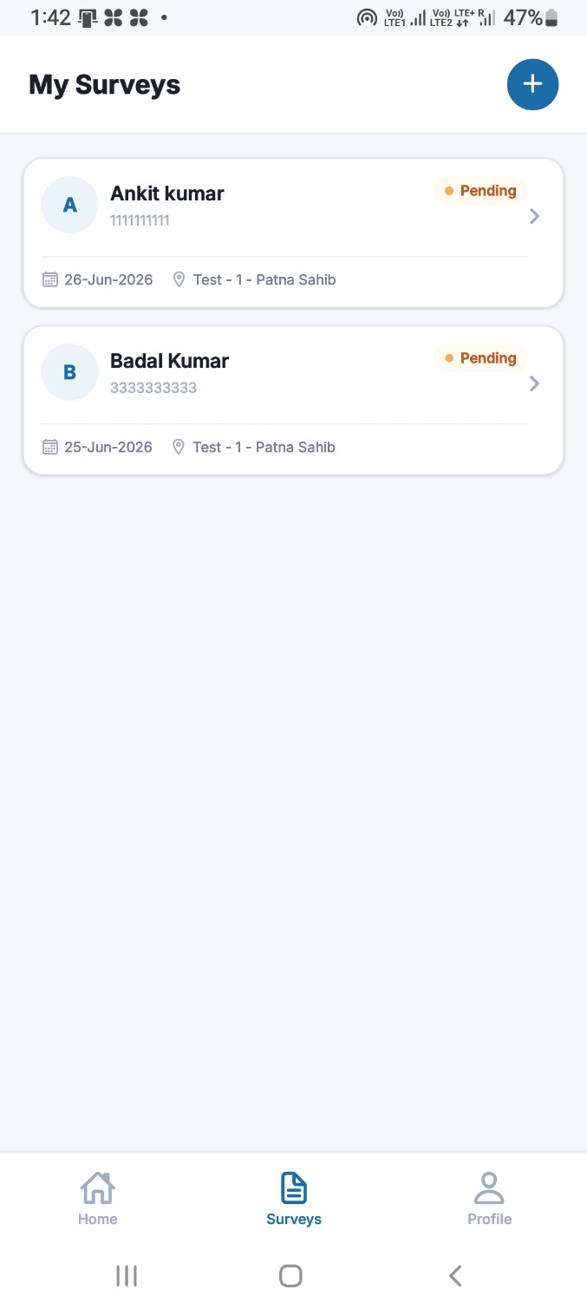
- Editing: You can edit the details or photos of a survey only if its status is "Pending" or "Rejected".

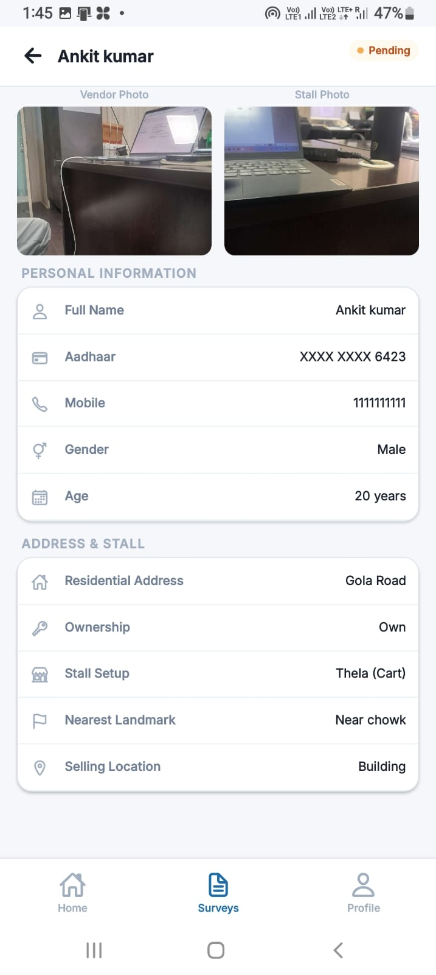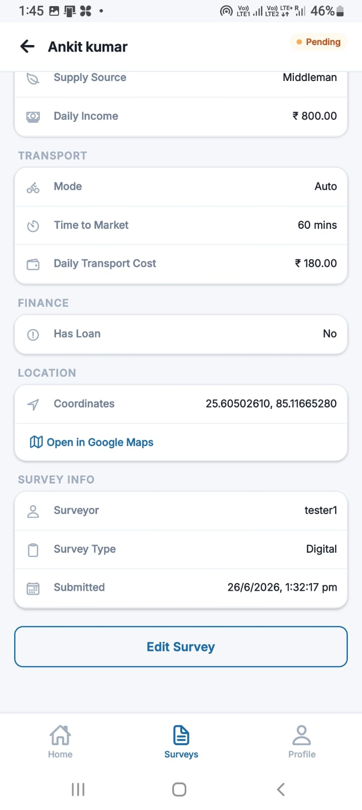

- Checking Status:
  - Approved: The survey was accepted, and a Unique Vendor Code (UVC) will be displayed.
  - Rejected: The survey was rejected. Check the Admin Remarks section to see why it was rejected, edit the required fields (e.g., retake a blurry photo), and resubmit.
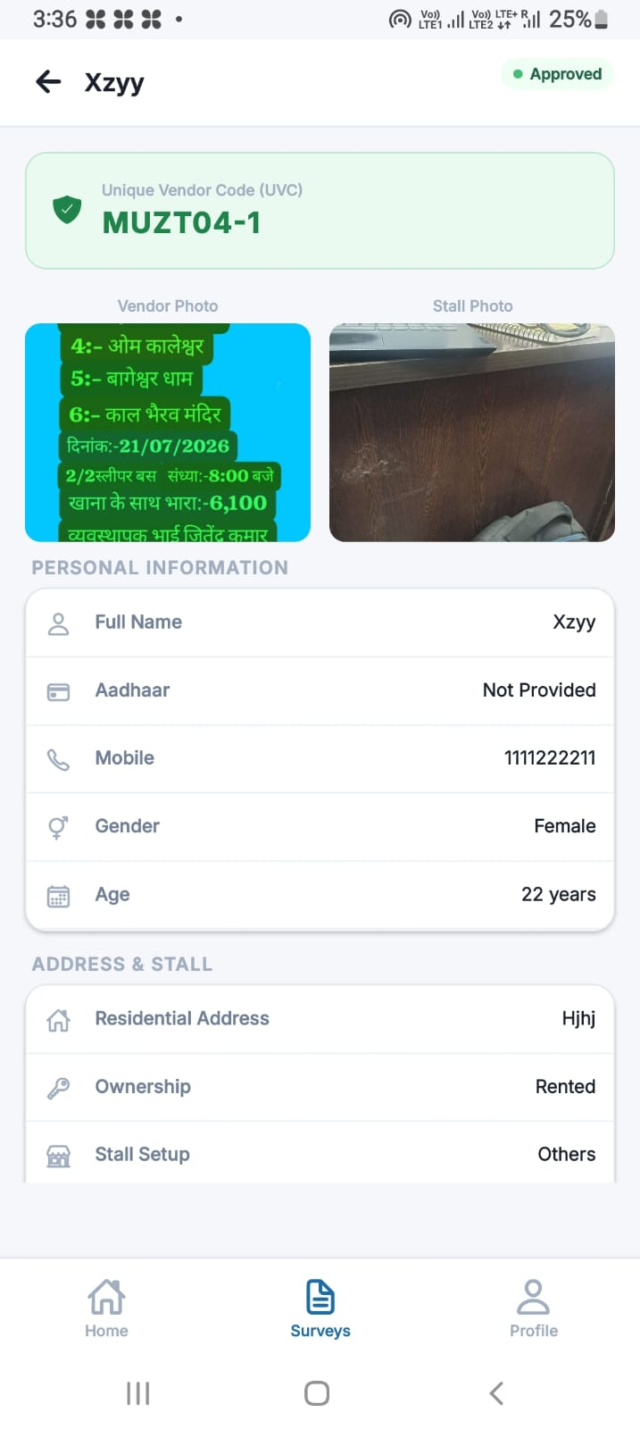

2. Web Admin Panel (For Administrators)
The admin panel is accessed via a web browser and provides a bird's-eye view of all incoming data.
Reviewing Surveys
- Log in to the admin panel using your administrator credentials.
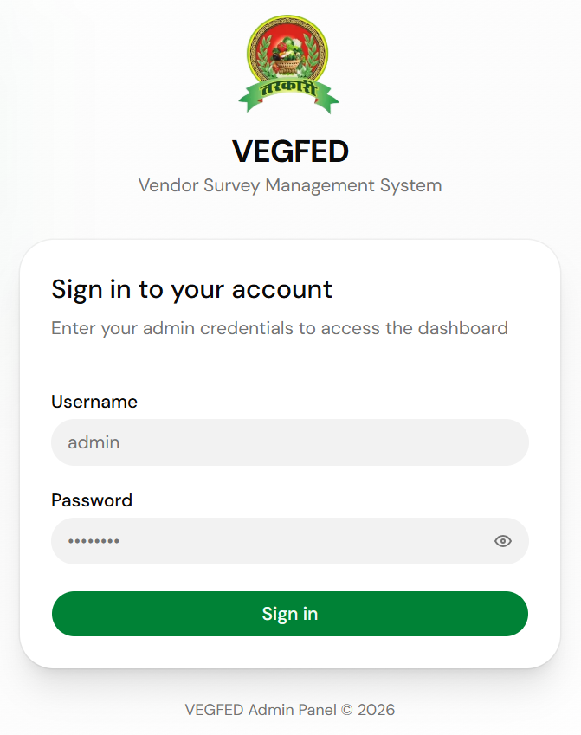

- You will be landed to a dashboard showing all vendors list.

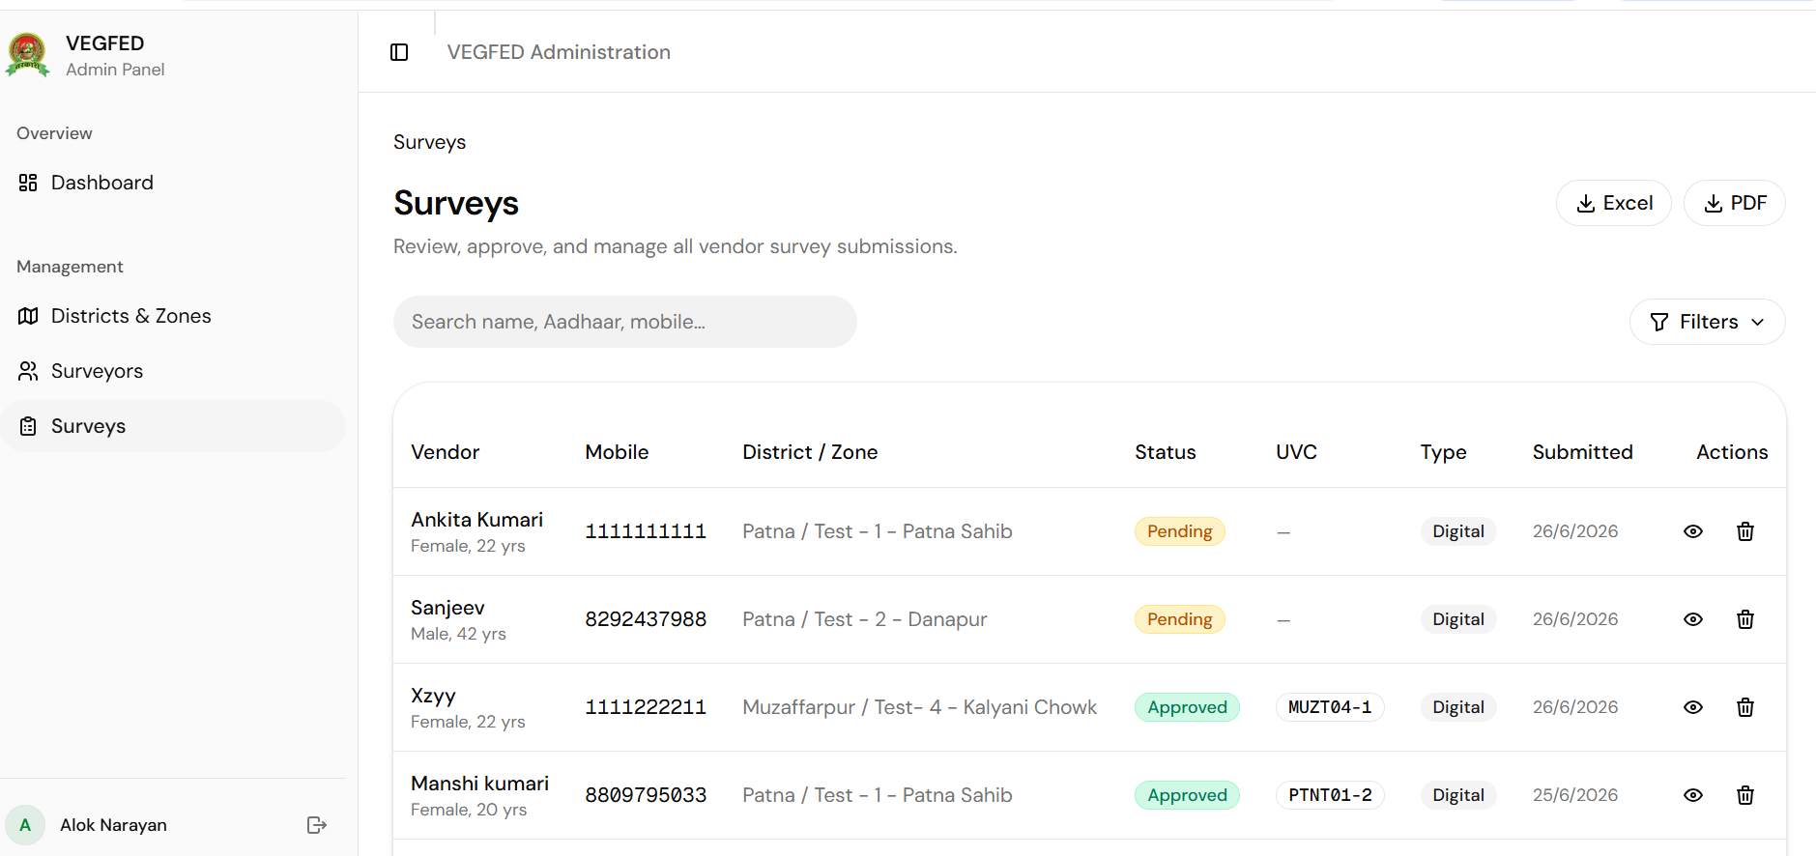

- Click on a specific survey ( to ) to view the vendor's personal information, business details, GPS location (viewable on a map), and uploaded photos.
Approving & Rejecting
- Approve: If all information is correct and the photos are clear, click Approve. The system will automatically generate a Unique Vendor Code (UVC) for that vendor, which will become instantly visible to the surveyor on their mobile app.
- Reject: If data is missing, incorrect, or photos are blurry, click Reject. You must provide Admin Remarks (e.g., "Vendor photo is too blurry, please retake") so the surveyor knows what to fix.
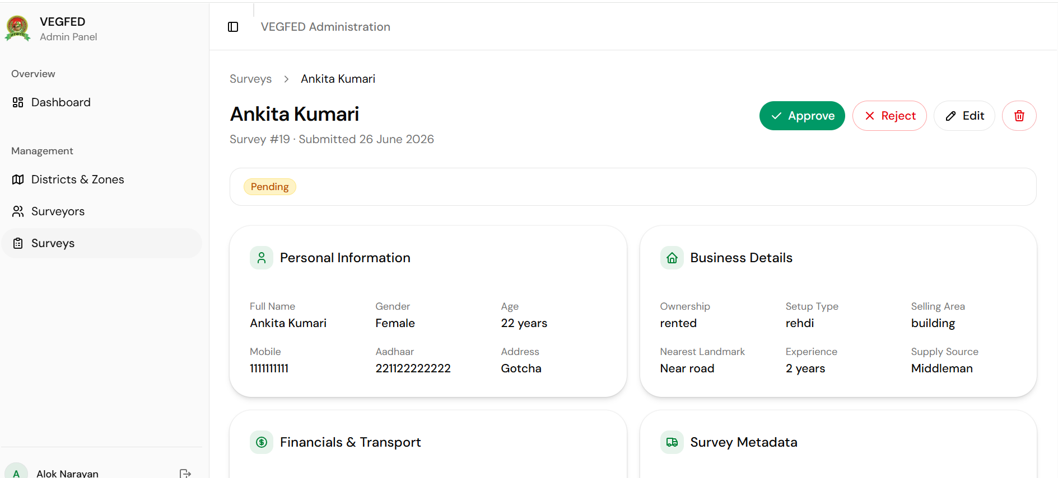

Managing Data
- Use the dashboard filters to search for specific vendors by name, Aadhaar number, or UVC.
- Filter surveys by District, Zone, or Date submitted for easy reporting and tracking.

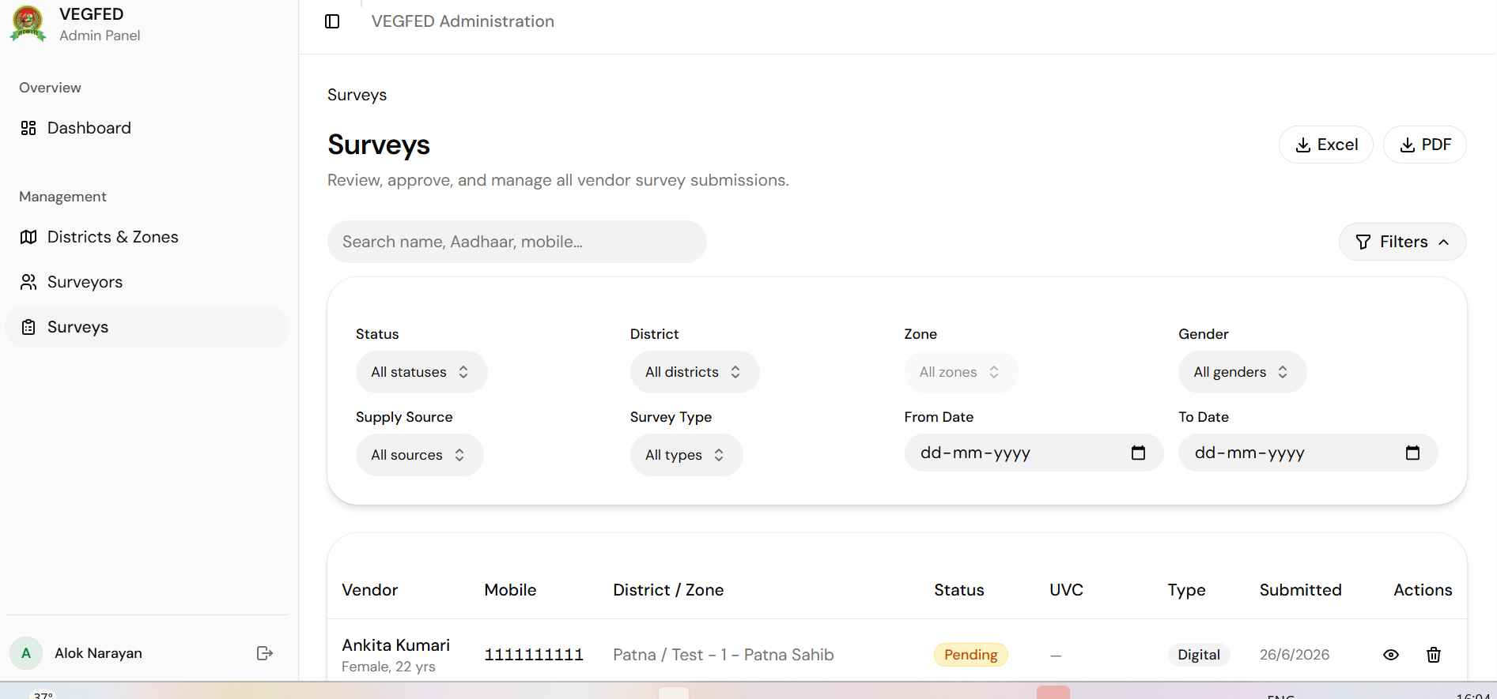

- Use the “Districts and Zones” page to add/manage districts and zones.

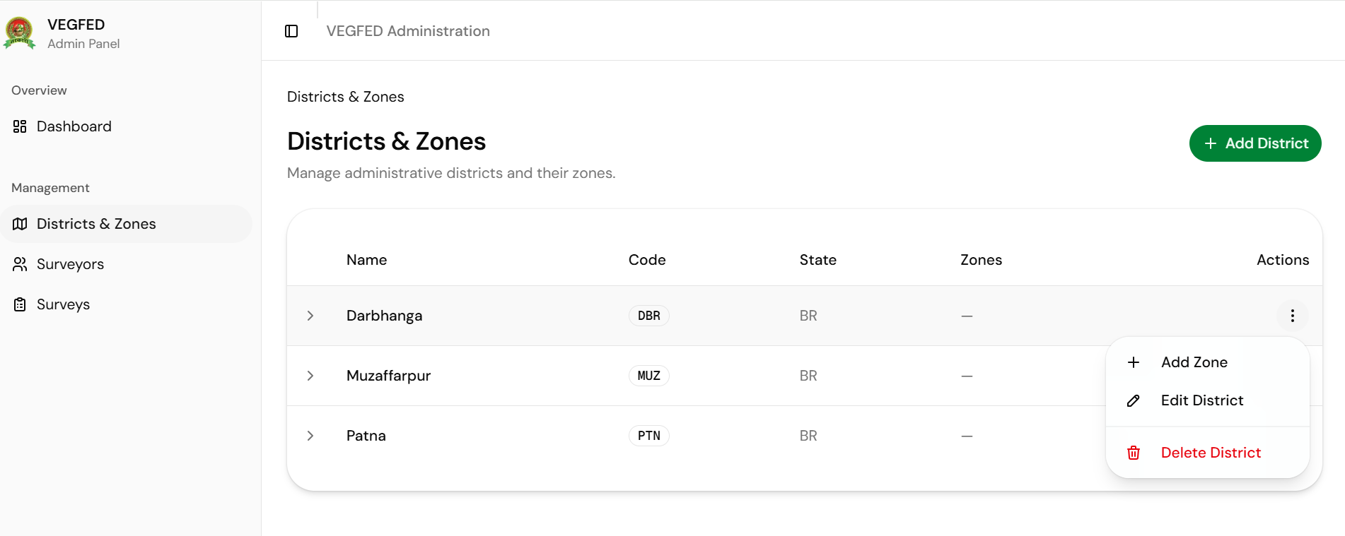

- Use the “Surveyors” page to add the Surveyors

